High Fen RC -Tammy Ruffles Flatwork Clinics
Tammy is a UKCC Level 2 Dressage Coach. She has enjoyed considerable success winning Area Festivals from Elementary up to PSG levels and has won an Area Festival National Championship at Medium Level. Some of her many achievements include the Sheepgate Tack and Togs Championship at Advanced Medium, qualifying for regionals at all levels up to Advanced Medium, Home Internationals at Elementary, Advanced Medium and PSG, Inter regionals, Inter Counties and the Hickstead Masters.
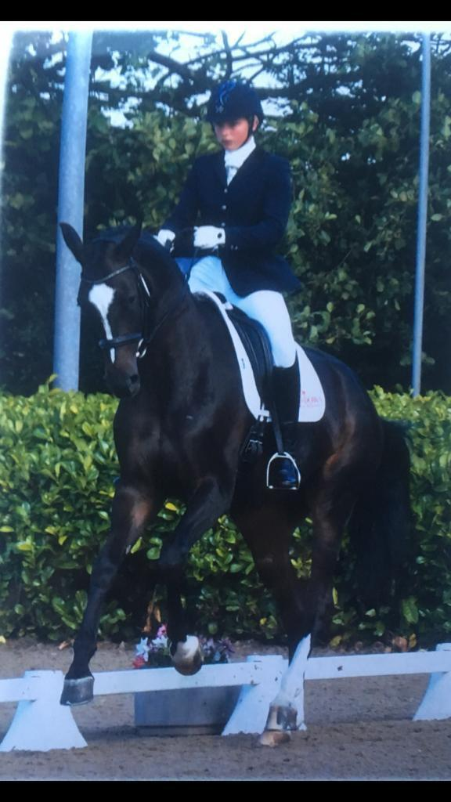
Clinics to be held at Holly Lodge Farm, Gt Horkesley - outdoor all-weather 60x20m arena with mirrors – CO6 4AW
Saturday 30th August
Sunday 21st September
Sunday 12th October
Sunday 16th November
All bookings to me @ neesymurf@icloud.com. By 12 noon the Wednesday before the clinic.
Payments to be made via the High Fen account upon booking.
There is also the option of booking via My Riding Life
Requests for early times will be allocated on a first come, first serve basis.

Prices –
30 mins private lesson – HF members £30 Non members £35
45 mins private lesson – HF members £40 Non members £45
(If two people wish to share an hour, please book two consecutive 30 mins slots. There can be no more than 2 riders in the arena at any one time so please don’t book for more than this)
Times will be sent to riders 4 days before the date of clinic and you will be required to sign a disclaimer for the use of the arena once booked.

🔹 CLINIC RULES – IMPORTANT INFORMATION 🔹

To ensure the safety and smooth running of our clinic, please take note of the following:
📌 Insurance Requirement – If you are not a full BRC member, you must have valid third-party insurance to attend.
📌 Emergency Contact (ICE) Details – In case of emergency, you must ensure the clinic organiser has your ICE (In Case of Emergency) details.
📌 Horse Transport in Emergencies – Your ICE contact should:
✔️ Ideally travel with you.
✔️ Be able to transport your horse home if needed.
✔️ If not present, they must be contactable and able to attend promptly to transport your horse.
📌 Bringing Children (Under 18)? – An adult ICE contact must be present for any under-18s attending.
Your cooperation is essential in keeping everyone safe and ensuring the clinic runs smoothly. Thank you!

#ClinicRules #SafetyFirst #BePrepared

Please contact Denise Lawry neesymurf@icloud.com 07734 233364 with any queries. Thanks.

