**High Fen RC -Tammy Ruffles Flatwork Clinics**

**Tammy is a UKCC Level 2 Dressage Coach. She has enjoyed considerable success winning Area Festivals from Elementary up to PSG levels and has won an Area Festival National Championship at Medium Level. Some of her many achievements include the Sheepgate Tack and Togs Championship at Advanced Medium, qualifying for regionals at all levels up to Advanced Medium, Home Internationals at Elementary, Advanced Medium and PSG, Inter regionals, Inter Counties and the Hickstead Masters.**

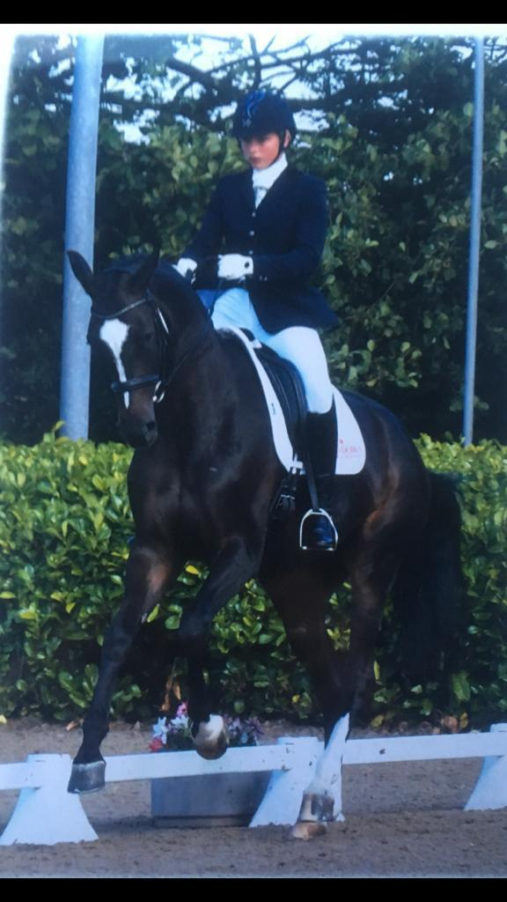

**Clinics to be held at Holly Lodge Farm, Gt Horkesley - outdoor all-weather 60x20m arena with mirrors – CO6 4AW**

**Sunday 21st April – 09:00 onwards**

**Sunday 19th May – 09:00 onwards**

**Sunday 2nd June – 09:00 onwards**

**All bookings to me @** [**neesymurf@icloud.com**](mailto:neesymurf@icloud.com)**. By 12 noon the Wednesday before the clinic.**

**Payments to be made via the High Fen account upon booking.**

**Requests for early times will be allocated on a first come, first serve basis.**

**Prices –**

**30 mins private lesson – HF members £30 Non members £35**

**45 mins private lesson – HF members £40 Non members £45**

**(If two people wish to share an hour, please book two consecutive 30 mins slots. There can be no more than 2 riders in the arena at any one time so please don’t book for more than this)**

**Times will be sent to riders 4 days before the date of clinic and you will be required to sign a disclaimer for the use of the arena once booked.**

**Insurance:** It is mandatory for anyone attending this event to have third party liability insurance. Therefore, anyone who is NOT a **full BRC member** attending must have separate insurance and should bring proof of their own third-party liability insurance to the event. (e.g BHS Gold or Harry Hall insurance cover)

**Please contact Denise Lawry** [**neesymurf@icloud.com**](mailto:neesymurf@icloud.com) **07734 233364 with any queries. Thanks.**